**ECSE 434 - Group 28**

**1 - VbAB**

**2 - nothing**

**3 - VcAB**

**4 - Vcc**

**5 - Vout**

**6 - Vee**

**7 - Vbias**

**8 - VoutD+**

**9 - VinD-**

**10 - VaD+**

**11 - VaD-**

**12 - Vcc**

**13 - VinD+**

**14 - VoutD-**

**15 - Vid**

**16 - Vee**

**17 - Vrab**

**18 - VinAB**

**19 - nothing**

**20 - Veab**

**Active loaded diff amp**

Voltage Transfer Curve

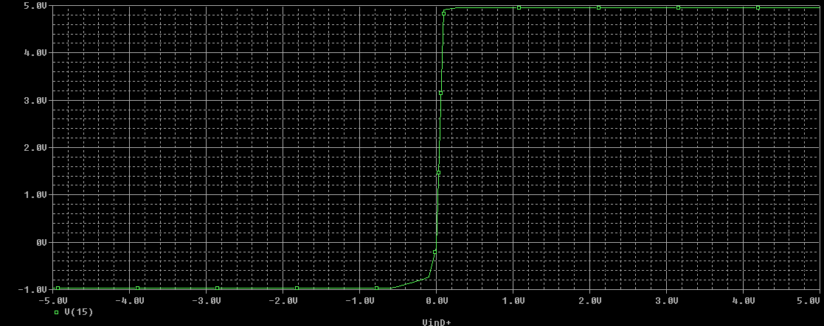

Single-ended frequency response

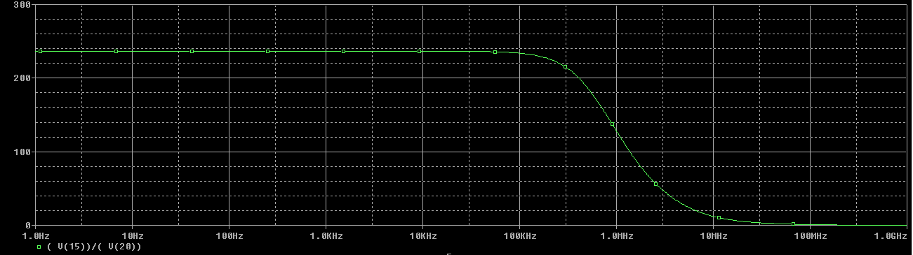

Transient Output

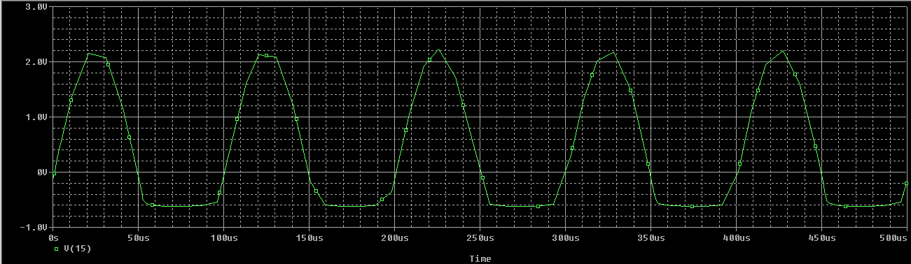

**Passive loaded diff amp - Rpa and Rpb set to 30kohm**

Voltage Transfer Curve

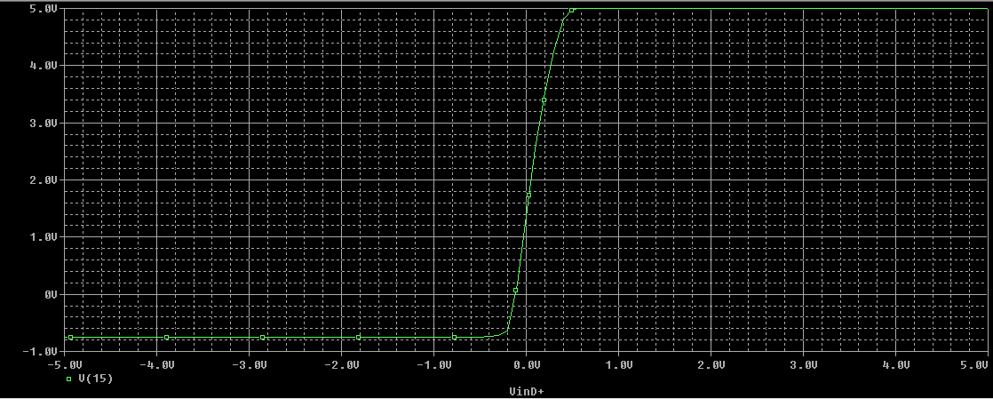

Single-ended frequency response

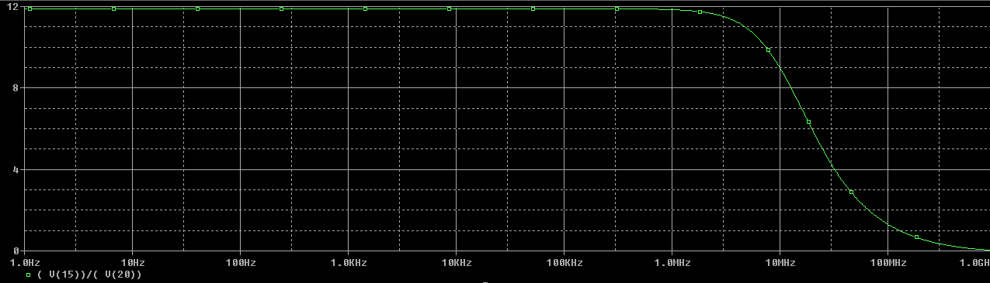

Differential frequency response – VinD+ at +5mV, VinD- at -5mV

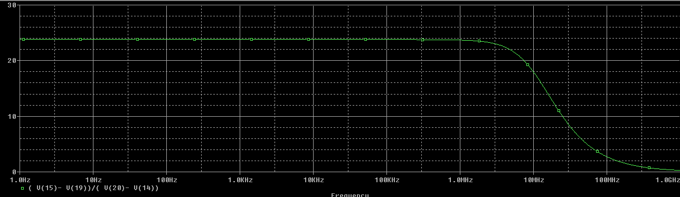

Transient Output

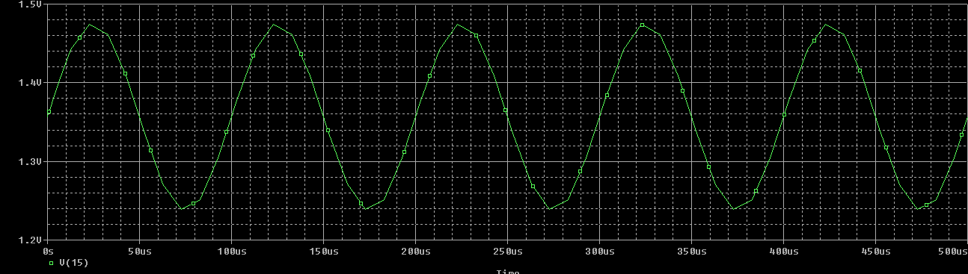

**Output Stage – tested with input biasing stage into a 330 ohm load.**

Voltage Transfer Curve

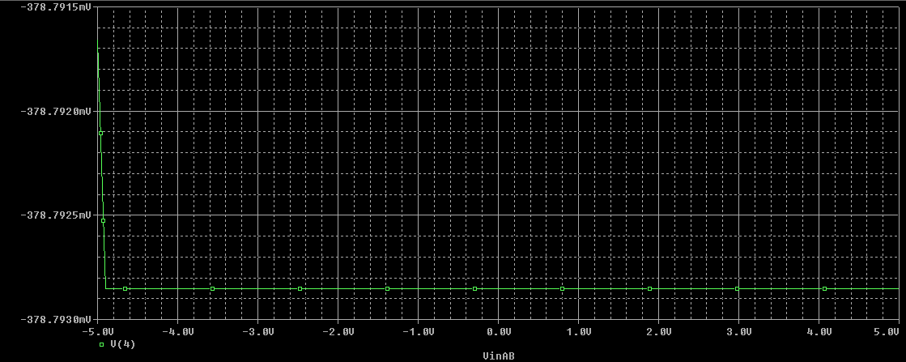

Single-ended frequency response

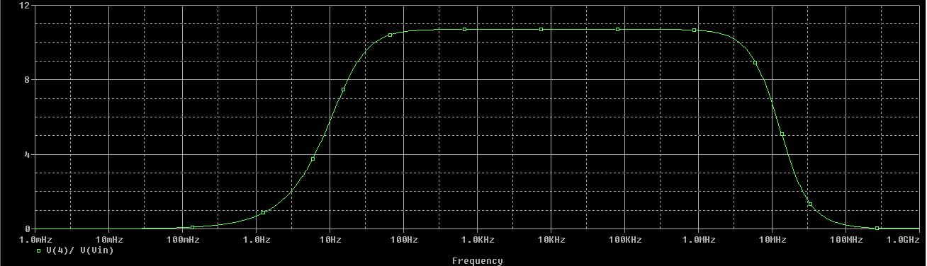

Transient Output

